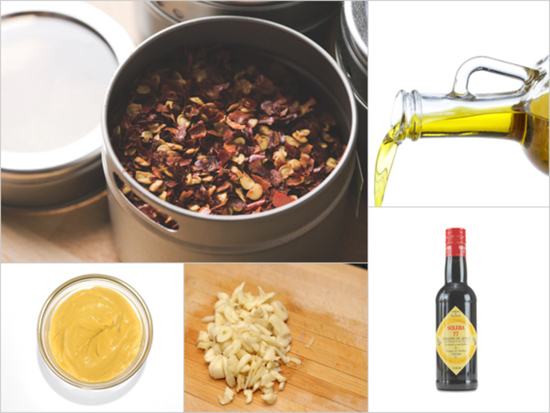

Sherry Vinaigrette
Whisk together the first four ingredients, plus salt and pepper to taste, and then slowly whisk in the oil. That’s one kicky vinaigrette.
- 2 Tbsp Sherry vinegar
- 1 tsp Dijon mustard
- 1 tsp minced garlic
- Pinch of red pepper flakes
- 6 Tbsp extra virgin olive oil
From the kitchen of Katie Kackenmeister
x 5 for 40-60 people

