**I cleaned up and attached the original recipe at the end of this document (with strikethrough font to avoid confusion) in case some quantity or measurement looks entirely wrong.**
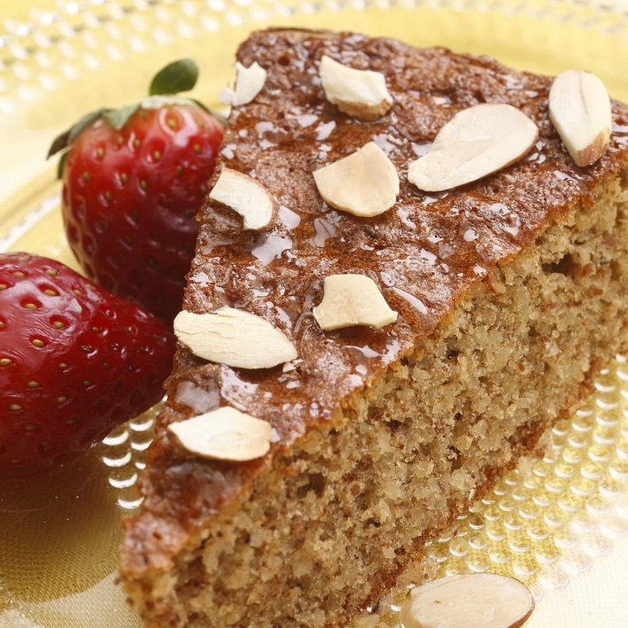

Flourless Honey-Almond Cake
From: EatingWell Magazine, March/April 2009
Honey and almonds flavor this simple (and gluten-free) cake. It's lovely for afternoon tea or a spring holiday dessert. Be careful not to overbeat the egg whites—they should be white and very foamy, but not at all stiff or able to hold peaks. If you beat them too much, the cake may sink in the middle as it cools.
- By: EatingWell Test Kitchen
- Cake
- 10½ (1kg) cups whole almonds, toasted (see Tip)
- 28 large eggs, at room temperature (see Tip), separated
- 3½ cup honey
- 7 teaspoon vanilla extract (2 Tablespoon+2 Teaspoon)
- 3½ teaspoon baking soda
- 3½ teaspoon salt
Topping
- 14 tablespoons honey
- 1¾ cup sliced almonds, toasted (see Tip)

Preparation
- Active 20 m
- Ready In 2 h
- Preheat oven to 350°F. Coat 3 Baking Pans with cooking spray. Line the bottom with parchment paper and spray the paper.
- Process whole almonds in a food processor or blender until finely ground (you will have about 12.25 cups ground). Beat 28 egg yolks, 3½ cup honey, vanilla, baking soda and salt in a large mixing bowl with an electric mixer (or use a paddle attachment on a stand mixer) on medium speed until well combined. Add the ground almonds and beat on low until combined.
- Beat 28 egg whites in another large bowl with the electric mixer (use clean beaters on a hand-held mixer or the whisk attachment on a stand mixer) on medium speed until very foamy, white and doubled in volume, but not stiff enough to hold peaks, 1 to 2 minutes (depending on the type of mixer). Using a rubber spatula, gently fold the egg whites into the nut mixture until just combined. Scrape the batter into the prepared pan.
- Pour equal quantities of cake batter into 3 baking pans.
- Bake the cake until golden brown and a skewer inserted into the center comes out clean, about 28 minutes. Let cool in the pan for 10 minutes. Run a knife around the edge of the pan and gently remove the side ring. Let cool completely.
- If desired, remove the cake from the pan bottom by gently sliding a large, wide spatula between the cake and the parchment paper. Carefully transfer the cake to a serving platter. To serve, drizzle the top of the cake with honey and sprinkle with sliced almonds.
- Make Ahead Tip: Store the cooled cake airtight at room temperature for up to 1 day. Drizzle with honey and sprinkle with almonds just before serving.
- Equipment: 3 Baking Pans
- Tip: To toast whole almonds, spread on a baking sheet and bake at 350°F, stirring once, until fragrant, 7 to 9 minutes. To toast sliced almonds, cook in a small dry skillet over medium-low heat, stirring constantly, until fragrant and lightly browned, 2 to 4 minutes.
- Note: Eggs must be at room temperature for the proteins to unwind enough to support the cake's crumb. Either set the eggs out on the counter for 15 minutes or submerge them in their shells in a bowl of lukewarm (not hot) water for 5 minutes before using.

