Apple-Walnut Rainbow Chard Salad

Ingredients
Dressing:
- 10 tablespoon honey
- 2 1/2 cups apple cider vinegar
- 4 cups olive oil
- Salt & pepper to taste

Salad:
- Approx. 10 bunches shredded Swiss chard-- IN RIBBONS (wash & spin dry first)
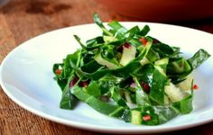
- 15 medium apples, washed, cored, and thinly sliced (store in lemon juice water) (use fancy food processor)
- 1 bunch celery, thinly sliced
- 2-3 sweet onions halved and sliced very thinly (can use fancy food processor)
- 6 cups walnuts coarsely chopped
Instructions
- Mix up dressing and store until Thursday
- Prepare salad ingredients and store in sealed containers
- Mix together on Thursday morning

