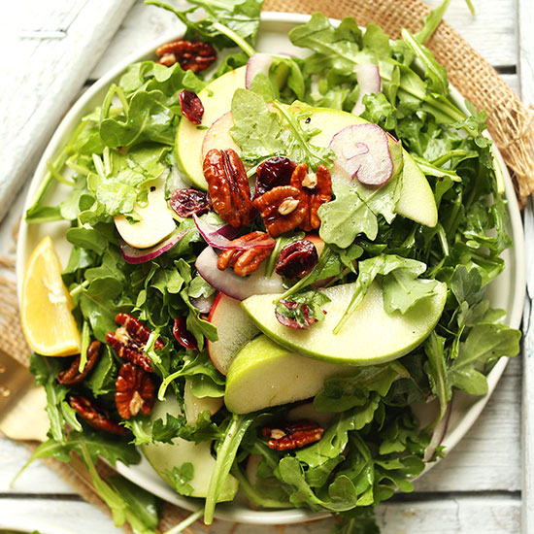
APPLE PECAN ARUGULA SALAD

Prep time
5 mins
Cook time
10 mins
Total time
15 mins

Ingredients

SALAD
- 5 cups raw pecans
- 8 lbs Arugula
- 30 small apples (or less if larger) washed, quartered, cored and thinly sliced lengthwise
- 5 red onions, thinly sliced
- 3 cups dried blueberries

DRESSING
- 3 cups lemon juice
- 1 cup maple syrup
- 1 cup Olive Oil
- sea salt + black pepper to taste

Instructions
- Prep Arugula—wash, spin dry and store (1 large stainless steel bowl + 1 1 plastic container with lid
- Prep Apples—Slice thinly… store in water with lemon juice in container in fridge …try to do this as close to Thursday as you can so they won’t go brown…
- Prepare dressing in a mixing bowl by adding all ingredients and whisking or shaking vigorously to combine. Taste and adjust flavor as needed.
- On Thursday -- Preheat oven to 350 degrees F (176 C) and arrange pecans on a bare baking sheet.
- Bake pecans for 8-10 minutes, or until fragrant and deep golden brown. Remove from oven and set aside for topping
- Arugula & Apples will be combined on Thursday with Dressing and Pecans on the side

