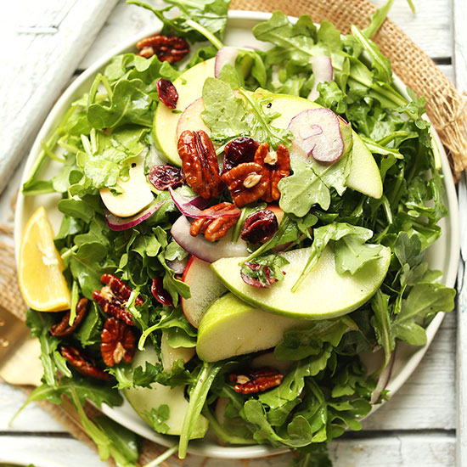

Arugula Apple Salad
- 2 large ice cream buckets of Arugula from Garden washed and spun dry broken into bit sized pieces and stored in container in fridge. If using same ice cream buckets, wash and dry first :-)
- 12-15 apples washed, cored and sliced into thin wedges. Store in sealed container in water with lemon juice completely covered so they don’t go brown
- 3 large red onions cut in half and then thinly sliced
- 4 cups cranberries
- Pecans on the side
Maple Lemon Dressing:
-3 cups lemon juice
-3 cups olive oil
-1 cup Maple Syrup
-salt and pepper
**TASTE and adjust accordingly :-)
Store in glass measuring cup with lid

