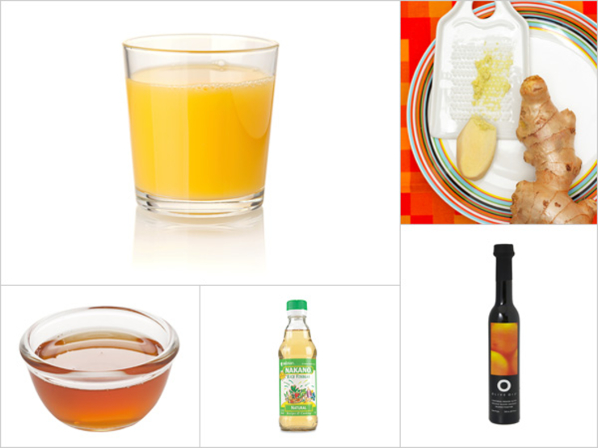

Asian Citrus Dressing
Five minutes is all it takes to make this dressing, which pairs well with both sweet and bitter lettuces. Whisk together the first three ingredients, then slowly whisk in oils until well combined. Double duty alert: It makes a primo sauce or marinade for fish or chicken. The dressing will keep, covered and chilled, for a week.
- ¼ cup tangerine juice (we used Noble brand)
- 1 Tbsp seasoned rice vinegar
- 1 ½ tsp finely grated peeled fresh ginger root
- 2 Tbsp organic blood orange olive oil (O olive oil brand) or canola or safflower oil
- 1 ¼ tsp dark sesame oil
From the kitchen of Lori Powell
x 8 for 40-60 people

