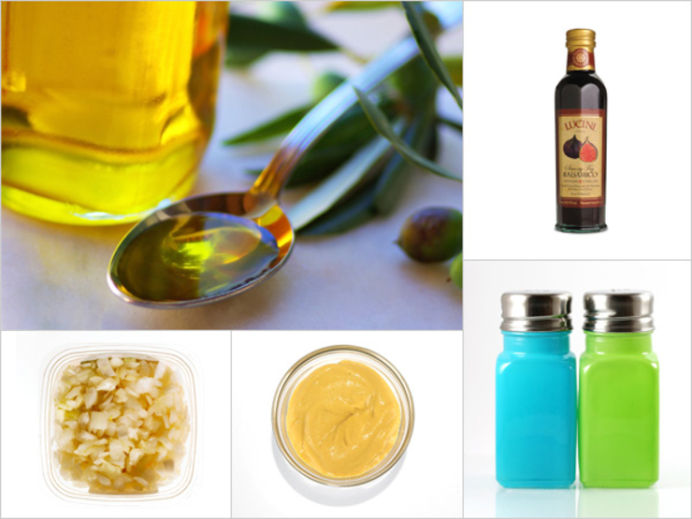

Basic Balsamic
As an everyday dressing, this one is tops. Whisk together the vinegar and mustard until it’s well combined; then, slowly whisk in the olive oil until it’s emulsified. (You’ll know when it’s lighter in color and mixed well.) Whisk in your onion or shallot, and season with salt and pepper.
- 2 Tbsp balsamic, cherry, or fig balsamic (Lucini) vinegar
- 2 tsp Dijon mustard
- 5 to 6 Tbsp extra virgin olive oil
- 2 Tbsp finely chopped shallot or sweet onion
From the kitchen of Lori Powell

x 15 for 40-60 people

