Big Batch Apple Sauce

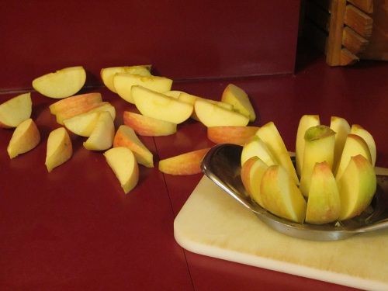
Cook up 80-100 Apples
Fill your largest stock pot full to the brim with sliced apples. Mix about ½ cup of lemon juice with about 1½ cups of water, and pour it over the top.

Put the lid on and cook the apples on medium heat until they are soft. 30-45 minutes, maybe?

Once the apples are soft, put them through the blender in batches until smooth. The peels are soft and really do “disappear” into the sauce. Give ’em a quick pulse and you’ll have applesauce.

Add some cinnamon & Sugar to taste
Store in container in fridge.

