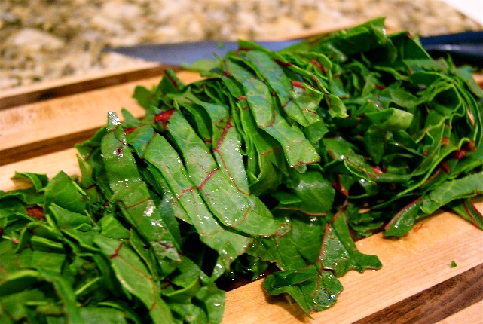

Chard, Golden Beet & Barley Salad

2 large ice cream buckets of chard, washed, spun and cut into ribbons
You can cut and include good quality stems as well

- 12 golden beets
- 4 red onions chopped
- 10 cups of cooked pearl barley (Heather is going to cook a batch of this up in her one pot for you at home)
- 6 cups of raisings
- 6 cups of pecans
- 3 cups feta cheese

GINGER TAHINI DRESSING:
- 1 cup tahini
- 1 cup water
- 1 cup lemon juice
- 10 garlic cloves (crushed)
- 1 cup maple Syrup
- ½ cup cider vinegar
- ½ cup grated ginger root
- salt & pepper

Instructions
- Heat the oven to 450°F. Wash, then loosely wrap the beets in foil and roast them in the oven until they are just fork tender, 30 to 45 minutes. Let cool enough to handle, then peel and dice the beets into 1/2-inch cubes.
- Chop onion
- Wash and cut chard in ribbons
- Make dressing in blender (store in covered measuring cup in fridge)
- Mix everything except dressing and feta cheese together. Fill one large stainless steel bowl to brim , cover and store and then have ¾ of an large ice cream bucket full as well for re-fills.

