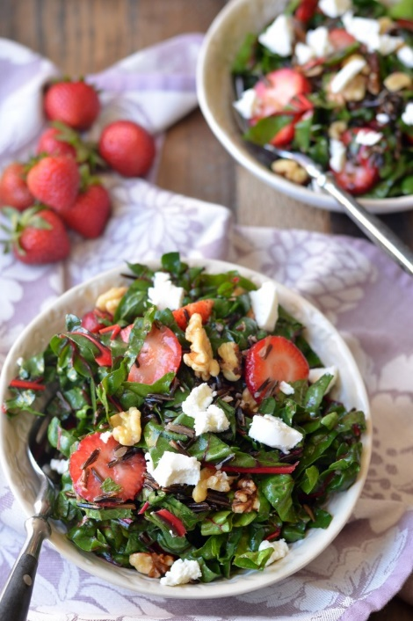
STRAWBERRY, SWISS CHARD AND WILD RICE SALAD

INGREDIENTS
For the salad:
- 14 cups dry wild rice prepared as directed… divide into two batches to cook in rice cooker :-)
- 2 ice cream buckets of chard, washed well, spun dry and cut into ribbons+ stems chopped up like celery
- Fresh mint leaves washed and spun dried stems off, thinly sliced
- 6 containers washed and sliced strawberries
- Walnuts on the side
- Grated Parmesan Cheese on the side

For the dressing
- 5 1/3 cup fresh lemon juice (about 1 1/2 lemons)
- 2 cups olive oil
- 2 cups honey

INSTRUCTIONS
- Cook Rice in two batches in rice cooker. Fluff and let cool… put in base of large stainless steel trays with lids
- Meanwhile, make the dressing by blending the lemon juice, olive oil, and honey in the blender… store in container in fridge (large jugs above stove)
- Prepare the chard, rinse out buckets and store back in buckets… put sticky note on it to say when prepared.
- Prepare sliced mint leaves & strawberries, and leave separate stored in fridge.
- Walnuts and Cheese will be served on side.

