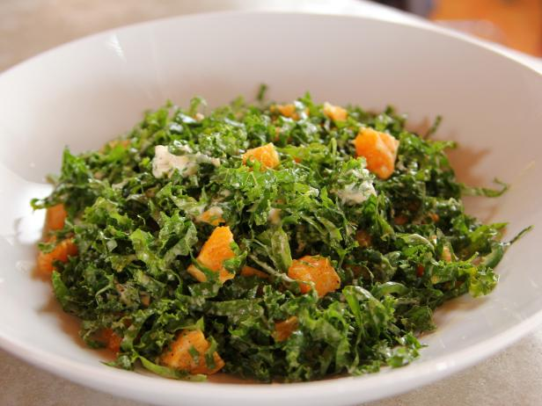

Citrus Kale & Chard Salad
-1 large ice cream bucket of kale from garden tough stems removed and cut into strips, washed and spun dry and then stored
-1 large ice cream bucket of chard from garden cut into ribbons, washed and spun dry then stored
-500 ml of feta crumbled and stored separately until Thursday
-12 oranges peeled and cut into bit sized pieces and stored separately until Thursday

Orange Ginger Sesame Dressing
2 cups orange juice
.5 cup rice vinegar
4 tbsp freshly grated ginger root
1 cup canola oil
4 tbsp sesame oil

