- 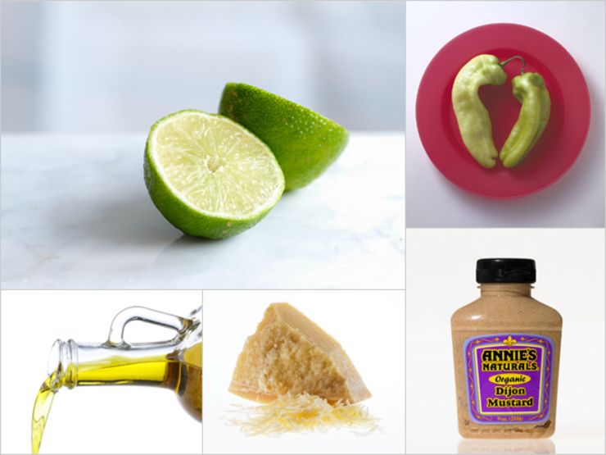

Creamy Jalapeno Kicker
This creamy, kicky dressing is addictive! It’s sturdy enough to pair with rough, raw greens like kale, sturdy Brassica like cabbage, and it works just as nicely with light field greens, too. The lime cuts the jalapeno, and the parm or nutritional yeast offer a nutty richness, too.
  - 1 lime, juiced
  - ½ tsp Dijon
  - 1 seeded and diced jalapeno pepper
  - 1/4 tsp extra virgin olive oil
  - 1 Tbsp of grated parmesan or nutritional yeast
From the kitchen of Siobhan O’Connor
x15 for 40-60 people

