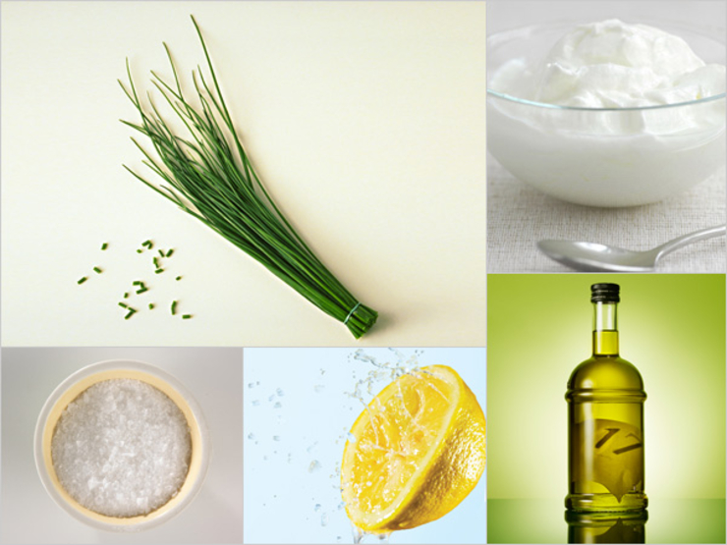

The Five and Chive
It doesn’t get more springy or savory than this creamy favorite, adapted from a recipe by cookbook writer Martha Rose Shulman.
- ½ c nonfat plain yogurt
- ¼ c extra virgin olive oil
- ¼ c fresh lemon juice
- ¼ tsp salt
- Chopped fresh chives to taste
From the kitchen of Miranda van Gelder
x2 for 40-60 people

