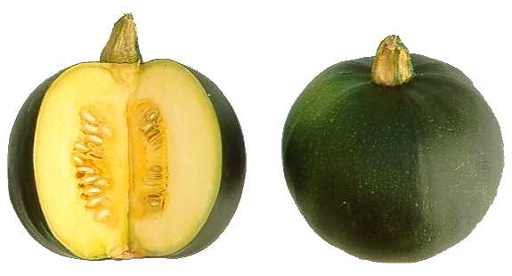
Gem Squash Salad

-Cut Squash in Half (15 squash for 60-70 people) & scoop out the seeds
-Julienne Cut raw squash into slender strands (store in airtight container)

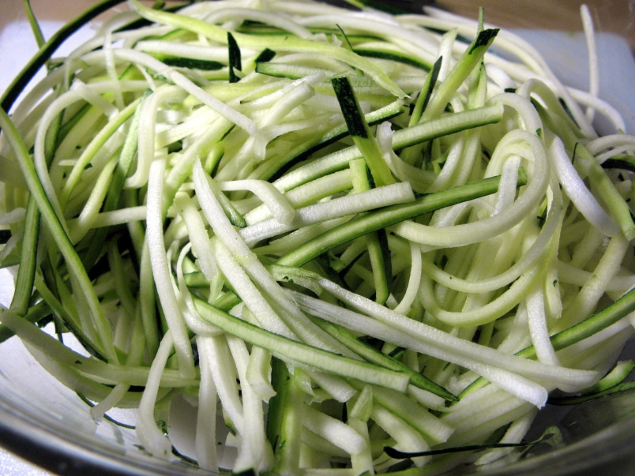

-Mix up dressing/marinade and store in glass measuring cup
(14 tbsp lemon juice, 14 tbsp olive oil, salt & pepper)
-Quarter 5 pints of cherry tomatoes and store in airtight container
-chop up fresh oregano & basil and store

-At 9:30am on Salad bar day, add dressing/marinade to squash and let sit for 1 hour
-after one hour drain off excess dressing
-Add tomatoes, oregano & basil plus one container of crumbled feta cheese

