Greens with Cucumber & Grated Beets

Wash well and spin dry greens (likely Arugula)
Make sure broken into bite sized pieces and store in large stainless steel bowl
Slice & quarter cucumbers and store in container with lid
Peel and grate beets (use food processor grating blade)… be careful can get beet juice everywhere… store in container with lid

Raspberry, Rosemary Vinaigrette Dressing:
Mix in Blender:
- 3/4 cup vinegar
- 3/4 cup olive oil
- 1 cup frozen raspberries (add more if needed)
- 3 TBSP honey
- 6 tsp minced onion
- 6 tsp chopped chives
- 6 tsp chopped fresh rosemary --from the courtyard --huge bush by apple tree to right of wooden arbor)
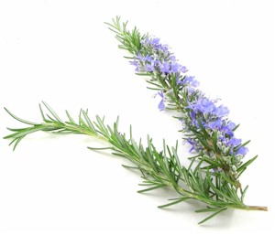
- salt & pepper to taste

