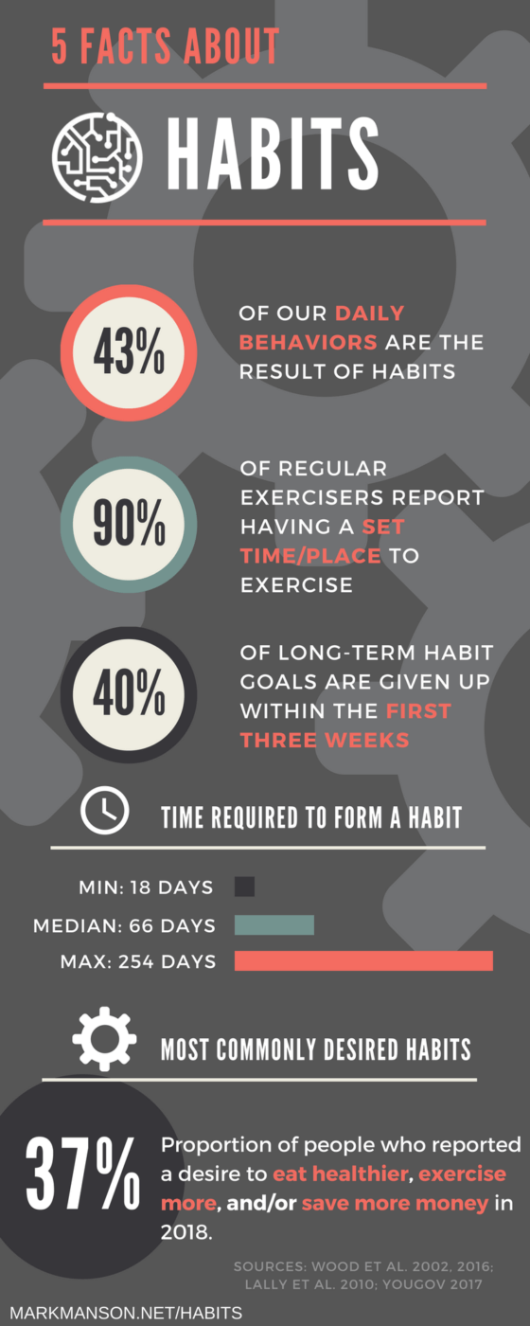
Thinking about your Habits
4 of my really great habits are:
_____________________________________
_____________________________________
_____________________________________
_____________________________________

The reason I keep these habits in my life is:

The good results I get from having each good habit are (e.g. I have a habit of smiling at people I meet, and now people are friendlier to me)

Some habits I have that are neutral (neither good or bad) are:

Right now my worst habits are:

The reason I have these bat habits:

How long have you had these bad habits?

What are the negative results you are experiencing from these bad habits?

What is the one habit you would like to change the most?
For most people a primary objective for doing what they do and working to change behaviours is to achieve more happiness… Here is something to consider as you intentionally engage to build positive habits in your life:

Loretta Breuning, author of Meet Your Happy Chemicals, says there’s a basic non-intellectual neurochemistry in us all behind these feelings, which is their driving force. Simply put, ‘your brain spurts happy chemicals which reward you with good feelings when you do something it perceives as good for your survival’.
We have two different brain systems – the limbic system and the cortex – which keep us alive and protect our DNA. The limbic system produces the neurochemicals that tell your body what’s good or bad for you. It’s a survival mechanism: in the presence of something good, the brain releases four main ‘feelgood’ chemicals – endorphin, oxytocin, serotonin, and dopamine – and in the presence of danger, the ‘bad feeling’ chemical – cortisol – comes in.
As humans, we have a large cortex, which means we can override ‘animal’ impulses, but the limbic system will keep tripping. ‘When we’re having a happy experience, the chemicals are metabolised; then the bad feelings come back and unhappy chemicals spread to fill that space, so then we want to trigger more happy chemicals,’ says Breuning.
So, we’re locked into happiness-chasing because these chemical surges mean we constantly need to find new ways to get a fix. This isn’t down to individual ‘weakness’, adds Breuning: ‘This hedonistic treadmill is entirely natural and not something we’re doing wrong.’ So, how do you boost them?
1. Trust and belonging: oxytocin Oxytocin is the ‘bonding’ chemical. If your trust has been betrayed, you’ll hold back, which can leave you feeling like you don’t belong. Build more trust by:
- Being trustworthy. If others know they can trust you, you’re more likely to feel you can trust them.
- Finding a proxy. Trust takes time to build, so you could get a pet that will be loyal, join a group where you won’t be judged, or play a sport where you can share ups and downs.
- Having a massage. Taking time to apply body lotion or face cream can also make a difference to feelings of wellbeing. As touch stimulates oxytocin, be more ‘cuddly’ with your partner, friends or family, too.
- Counting your change. Verify your trust. This helps you to become able to build trust with strangers rather than staying with who you know.
2. Euphoria and determination: endorphin Endorphin is nature’s pain relief – it’s stimulated by pain. It evolved for survival; we need it to switch on and off so we don’t end up walking on a broken leg, for example. Find the right amount to push you through pain and promote wellbeing.
- Laugh. A true belly laugh will ‘shake up’ your insides in a good way. Genuine laughing (which makes your face ache) is thought to release fear.
- Cry. Holding back tears can build up tension, whereas if you let it go when you need to, it’s a physical relief from tension generally in the body, and especially in the diaphragm.
- Exercise. But change it around, as working the same muscles leads to wear and tear or injury. Feeling uncoordinated is the point – ‘new’ movement is how you get the endorphin rush. Make it fun, so that you laugh at the same time.
- Stretch. It’s a great way to boost circulation. Try a yoga or Pilates class, which will go even deeper. The idea is to stretch those muscles you never even knew you had.

3. Motivation: dopamine Dopamine helps us release the energy we need to get the rewards we want. In survival terms that usually means food and water, but we can benefit from it in other ways:
- Take baby steps. The idea of breaking down a tough task you have to get done makes it feel more do-able. Your brain will reward you with dopamine each time, helping you achieve the goal.
- Do a victory dance. Congratulating yourself on any little achievement will make you feel good. It might not give you the huge surge a marathon runner gets crossing the finishing line, but it feels much better than one-upmanship.
- Raise the bar slowly. No matter how much you want to, it’s hard to go from not cooking to often hosting a big dinner party. Make your goal realistic to begin with, and build from there.
- Act. Set aside 10 minutes a day to work on concrete actions and dopamine will help you generate the energy to do so.
4. Safety and respect: seratonin In a mammal, seratonin is released when it sees it’s bigger or stronger than another; having the advantage creates a feeling of safety. Social recognition can be fleeting and unpredictable, but you can find good routes to self-respect:
- Enjoy where you are. It’s not always best to be in the driving seat, so know when to be happy to be the passenger. Status goes up and down.
- Notice your influence. Without being controlling or arrogant, you can see when people have taken your lead. Don’t expect credit, just take time to appreciate your good effect on others.
- Surrender control. Much of the time we can’t control what’s happening and that can be a big source of frustration. Choose one control ‘habit’ you have and try to let it go. So, no checking the weather or looking at the clock.
- Take pride. Make up your mind to say ‘look what I’ve done’ without being too tied up with the reaction – accept that it may not always be the one you want.

