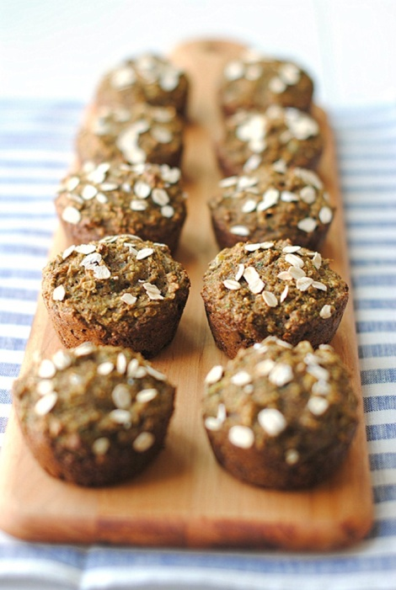
Juice Pulp Muffins

PRINT
Recipe adapted from Never Homemaker
Serves: 24 muffins (make 3 batches for a salad bar)
Can make ahead and freeze :-)
INGREDIENTS
- 3 cups whole wheat flour
- ¼ cup flax seed meal
- ½ tsp. salt
- 1 Tbsp baking powder
- 1 tsp. cinnamon
- ½ tsp. nutmeg
- 2 cups fruit/veggie pulp
- ½ cup plain Greek yogurt
- 1 cup apple sauce
- ½ cup maple syrup or honey
- 1 tsp. vanilla extract
- Optional...other things like frozen raspberries, raisins, chocolate chips

INSTRUCTIONS
- Preheat oven to 350 degrees F.
- In a large bowl, combine the flour, flax meal, salt, baking powder, cinnamon and nutmeg together. Then add in the pulp followed by the yogurt, apple sauce, maple syrup/honey and vanilla extract.
- Mix until just combined and add more apple sauce if too thick.
- Add batter to lined muffin tins. Bake for 20 to 25 minutes. Muffins will be done when a toothpick inserted into the middle comes out clean. Enjoy!

