Kale, Red Cabbage, Carrot Slaw with creamy dressing

- Wash, spin DRY and SHRED (with knife)--Really Thin!... 6 lbs kale
DON'T FORGET TO TAKE OFF THICK STEMS :)
Black Kale look like this: Green Kale looks like this: Red Kale looks like this:
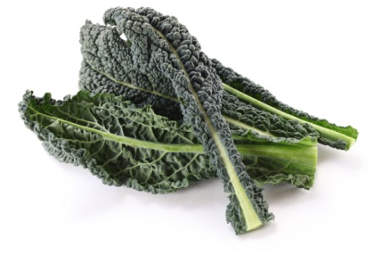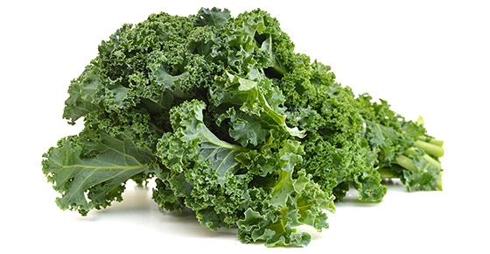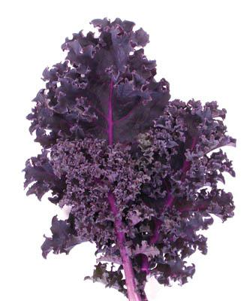
- Wash and SHRED (with knife)--Really Thin!...1-2 red cabbage
- Wash and GRATE (use food processor)... 15-20 carrots
- Store in large plastic container in fridge

Dressing
In a blender mix
3 cups mayonnaise
16 tablespoons malt, cider or rice vinegar
4 tablespoon granulated sugar
4 tablespoon light brown sugar
Salt and pepper, to taste
store in airtight container in fridge

For day of salad bar--- first thing in morning mix dressing with kale, cabbage and carrot to let marinate in fridge.

Serve with or sunflower seeds

