Kale, Chickpea & Feta Greek Salad

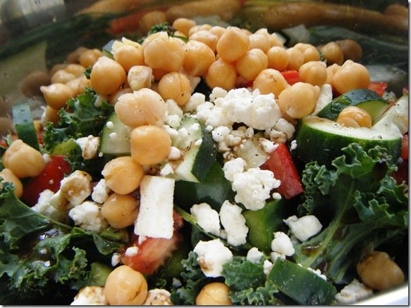

Ingredients:
- 12 bunches (washed & trimmed into bite size pieces SMALL)
- 6 cans chickpeas (drained & rinsed)
- 1.5 container of feta cheese drained and crumbled
- 8 cartons cherry tomatoes ½’d
- 8 cucumbers chopped
- Lemon Juice, olive oil, salt & pepper to taste – make 2 cups worth

Instructions:
Distribute the kale, chickpeas, tomato, cucumber, into a large stainless steel bowl + one bin.
Drizzle on the olive oil & lemon juice sprinkle on salt and cracked pepper to taste and mix prior to Thursday. Add Feta cheese on Thursday morning before serviving.

