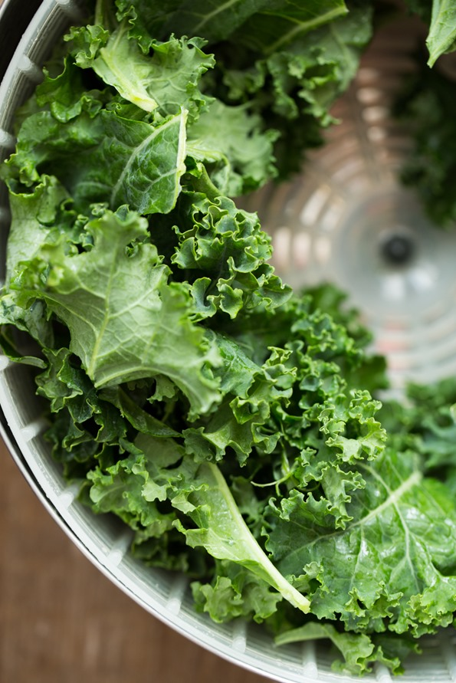
1. Remove the stems and tear leaves into large pieces
I don’t know about you, but I’m not a fan of chewing through woody baked kale stems. I remove the stems very quickly by grabbing the base of the stem with one hand and pushing outwards along the stem to slide off the leaves. Works like a charm!

2. Wash and thoroughly dry the leaves before beginning
If the leaves aren’t properly dried, the water can “steam” the kale chips while baking and lead to the dreaded soggy kale chip! Be sure they are nice and dry before you massage in the oil. A salad spinner works great; just be sure not to overload it so the leaves can properly dry.
3. Don’t skip the oil, but don’t drench it in oil either
A little bit of extra virgin olive oil (or coconut oil, if you prefer) goes a long way. I like to use ½ tablespoon of oil per baking sheet of kale chips. “Massage” the oil into the leaves to ensure all the nooks and crannies are coated. Oil also helps the spices stick to the leaves.
4. Spread kale into a single layer on the baking sheet
I used to dump all the kale into a very thick layer on the baking sheet and hope for the best, but doing this tends to lead to soggy, unevenly baked kale chips. I’ve learned to be a bit more patient and spread them out into a thinner layer on each baking sheet. Be sure to rotate the baking sheet half-way through baking. There’s no real need to flip the chips unless you have the patience for it.
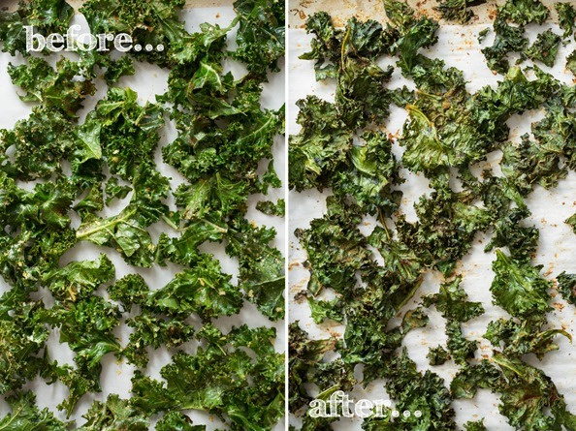
5. It’s all about the low-heat for even baking
As I wrote in my cookbook, I tested all kinds of kale chip recipes at different temperatures from very low to high heats. Surprise, surprise the batches that worked the best were the ones I baked at a very low temperature of 300F. Sure, it takes a bit longer to bake, but I can assure you it’s worth it because you don’t get any burnt pieces. Remember, the goal is to crisp the kale, not scorch it into smithereens! In my oven, I bake at 300F for 10 minutes, then I rotate the pan, and bake for another 15 minutes. So 25 minutes total for kale chip perfection in my oven. This will vary based on your oven, but it’s a good starting off point!
6. Cool for just a few minutes on the baking sheet
I’ve found that waiting just 3 minutes allows the kale chips to crisp up even more once they are out of the oven. Just like baked cookies or roasted chickpeas, kale chips really firm up even more when cooled. Those 3 minutes will feel like hours though. I won’t lie.
Bonus tips: Avoid adding liquids (such as vinegars or hot sauces) pre-baking as liquids can result in soggy chips. It’s best to add a light spritz of liquid seasoning after they’ve been baked, if at all. Also, if your oven has one, feel free to try out the dehydrator or convection setting.
Now, read on for my All-Dressed Kale Chip recipe! I promise this batch will not last long…minutes while standing in front of the oven if you are like me.

All-Dressed Kale Chips
Vegan, gluten-free, grain-free, nut-free, refined sugar-free, soy-free

Ingredients:

per baking sheet:
- approx. 1/2 bunch kale leaves
- 1/2 tablespoon extra virgin olive oil or melted coconut oil
- 1.5 tablespoons nutritional yeast
- 1 teaspoon garlic powder
- 3/4 teaspoon chili powder
- 1/2 teaspoon onion powder
- 1/2 teaspoon smoked paprika
- 1/4 teaspoon fine grain sea salt or pink Himalayan sea salt

Directions:
- Preheat oven to 300F. Line a large rimmed baking sheet with parchment paper.
- Remove leaves from the stems of the kale and roughly tear it up into large pieces. Compost the stems (or freeze for smoothies). Wash and spin the leaves until thoroughly dry.
- Add kale leaves into a large bowl. Massage in the oil until all the nooks and crannies are coated in oil. Now sprinkle on the spices/seasonings and toss to combine.
- Spread out the kale onto the prepared baking sheet into a single layer, being sure not to overcrowd the kale.
- Bake for 10 minutes, rotate the pan, and bake for another 12-15 minutes more until the kale begins to firm up. The kale will look shrunken, but this is normal. I bake for 25 mins. total in my oven.
- Cool the kale on the sheet for 3 minutes before digging in! This really makes all the difference! Enjoy immediately as they lose their crispiness with time.
- Repeat this process for the other half of the bunch.

