Kale Quinoa Salad

See Video for some tips on taking Kale leaves off stems and chopping + cooking quinoa: https://youtu.be/RZF2Z3ZOJhI

Some things have been changed to scale up to service a much larger amount of people

Step 1:

MARINATED KALE:
- 3 large ice cream buckets of kale leaves
- 15 tbsp extra virgin olive oil
- salt and pepper to taste

Take kale off stems & chop (watch video)
Wash and spin very well and put in large bowl
Add the olive oil and salt and pepper and massage into the kale with clean hands
Let sit for about 30 minutes

Step 2:

MAKE QUINOA:
- make 2, 7 cup batches of quinoa
- 14 cups water for each batch

Get two large pots
Put 14 cups of water in each pot
Measure out 7 cups of quinoa and rinse in fine mesh strainer… put into one of the pots
Measure a 2nd 7 cups of quinoa and rinse in fine mesh strainer… put into the other pot
Bring both pots to simmer over medium heat then leave for 12 - 15 minutes until all water is absorbed.
Remove from heat, leave lid on, and rest for 5 - 10 minutes. Fluff with fork then cool

Put Quinoa distributed into two stainless steel trays:
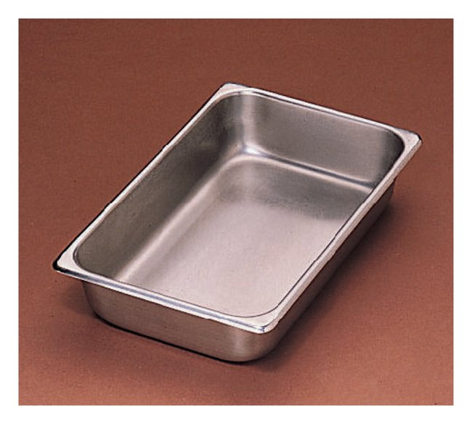

Layer marinated kale on top, add lids and store in fridge.

Step 3:

DRESSING:
- 2 1/3 cups lemon juice
- 2 ¾ cups extra virgin olive oil
- 1/3 cup Dijon mustard
- 15 garlic cloves , minced Check out Jamie Oliver’s Video on dealing with garlic… we also have a garlic press in the kitchen you can use if you do not want to mince with a knife
- 2.5 tbsp each salt and pepper

Mix dressing in blender and store in large covered measuring cup in fridge

Step 4:

Other ingredients to prep for thursday:
- 4 cups dill leaves , washed and roughly chopped
- 4 cups cilantro leaves , washed roughly chopped
- 10 red onions , quartered and finely sliced
- Slivered Almonds on side
- Crumbled feta on side

Store in containers in fridge

Everything will be put together Thursday morning.

