This Year…

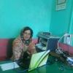
Atiya
Education provider
Pakistan
Building school
3% funded
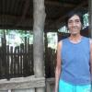
Adelina
Agriculture
Philippines
Pigs
76% funded
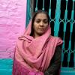
Naheed
Education provider
Pakistan
Buying desks for students
56% funded
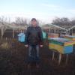
Ion
Farming
Moldova
Installing irrigation
81% funded

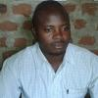
Jesus Cares N/p...
Education provider
Uganda
Installing water fountain
64% funded
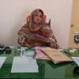
Sadia
Education provider
Pakistan
Buying supplies
35% funded
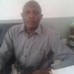
Lisa P. School
Education provider
Uganda
Water filters in school
33% funded
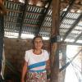
Ana Ofelia
Crafts
El Salvador
Making sleeping mats
50% funded

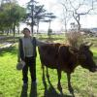
Prene
Personal Medical
Albania
Eye Sugary
56% funded
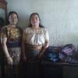
Dúo Victoria 3 ...
Weaving
Guatemala
Making traditional fabrics
83% funded
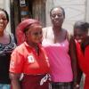
Tinashe Group
Bricks
Zimbabwe
Women making bricks out of raw materials
78% funded
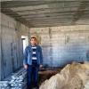
Islam
Personal Housing
Palestine
House was demolished
40% funded
Last Year…

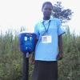
Brenda's Group
Health
Kenya
Clean drinking water
0% repaid
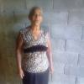
Guadalupe
Personal Housing...
El Salvador
Fixing the roof and floor
100% repaid
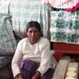
Narcisa
Agriculture
Bolivia
Purchasing cattle
69% repaid
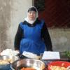
Gulnoz
Higher education...
Tajikistan
Son’s Tuition
66% repaid

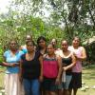
Banco Mujer Bulwak Group...
Farming
Costa Rica
Buying Animals
88% repaid
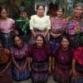
Flores De Chont...
Food
Guatemala
Tamale and Textile Business
100% repaid
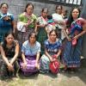
Costureras Clar...
Animal Sales
Guatemala
Purchasing chickens
100% repaid
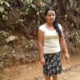
Beatríz Alejandra
Livestock
El Salvador
Buy 3 cows
100% repaid

