LEADERSHIP COURSE minimum REQUIREMENTS
1. Attend the mandatory meetings at lunch starting at 11:30 am in Room 32
Every non-holiday Monday
First Tuesday of every month

2. Complete a minimum of 30 hours of Leadership service time, and keep an electronic record of date, description, time contributed in the spreadsheet on our google classroom
Beyond the mandatory meetings (#1) you will be meeting with your leadership coach(es) and other students to plan and organize your activities/projects. You may also volunteer to help others in the school and community and/or take further leadership training beyond Reynolds. All of these things can count towards your personal leadership time for the year. The 30 hours are a minimum. We just want to make sure that even very busy people can take part in this program to an extent that fits in with other commitments.

3. Be involved as a main leader in at least one individual or team project/activity (BIG or small) and compete the final reflection for that activity in your journal as well as a summary of your project through google forms. The Reynolds Leadership Program is a "learn by doing" program. By leading your own activity/project you will learn a great deal. By submitting a summary of what you did and what you learned through the class google form it will be available to help others with the project in the future. Choose projects at a level which will challenge you to develop your own personal leadership skills further.
Examples of big= Spring Fair, School Dance, Famine for Ecuador…
Examples of small= Jelly Bean Count, Locker Decorating contest…

Projects typically fall under the headings of:
Spirit Fingers-- Promoting a positive school tone & culture and having fun (Intramurals, spelling bee, dance, battle of the bands, spirit days)...
Open 4 Change-- Supporting Social & Global Responsibility initiatives (Shoe box Hampers for disadvantages, potato socks for homeless, fundraisers for disaster relief, helping adopted village in Ecuador)...
Get REAL Green Group-- Helping with the Environment, being Earth Friendly (raising chickens, maintaining school garden, recycling, salad bar)...
4. Set and achieve your own personal leadership goals & maintaining an ongoing planning & reflective journal.
The first semester in leadership is for “getting your feet wet” –trying things out, determining how leadership will fit in with your other commitments for the year. In the second semester you will set your own personal goals for stretching and growing in leadership. You will be assessed based on achieving the minimum requirements and meeting your personal goals. The job of your leadership coaches is to help you set goals that are not too low or too high for you, and give you coaching as you engage in projects to make a difference and build your skills. You are strongly encouraged to sign up for individual or small group appointments with your leadership coaches to help you along the way and get the most out of your journey. Goals will be submitted through google forms. Journals will be submitted for feedback.

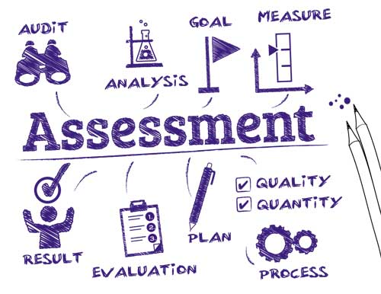
5. Submit a final Self-Assessment through google forms
Your final grade in the course will be determined by how well you set and meet your own personal leadership goals. Your final self-assessment is the place where you will reflect on how you stretched and grew your leadership skills & involvement during the year. Remember that regular attendance (#1) a minimum of 30 hours of contributed leadership time (#2) and organizing one activity as the main leader (#3) is required for an official leadership course credit. If these are not achieved then you will be removed from the official course and be considered a ‘leadership club’ member.

Our mission: is to gather together as a group of individuals and through teamwork, skill development and training, engage in the organizing, planning and follow-through of events and activities in order to contribute to both our school and broader community, while in the process undergoing personal positive growth.
Our Motto:" Make a Difference, Make it Happen! "​

