LEADERSHIP GOALS
Name: ___________________________ Grade: _______
Why did you choose to be in leadership this year?
_________________________________________________________________________________
_________________________________________________________________________________
_________________________________________________________________________________
How many hours are you aiming to contribute by the end of this year?
What 2 main leadership skills do you wish to stretch and grow in this year?
_______________________________ ___________________________
Where is leadership on your priorities of things you are involved in this year on a scale of 1-10
(1 being lowest, 10 being highest)? Circle where you are.
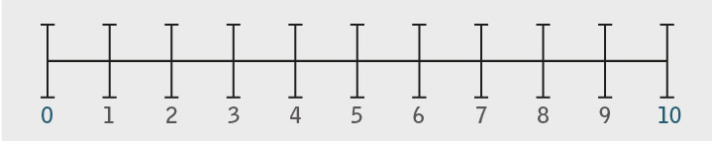
How do you fit leadership in to your schedule?
_________________________________________________________________________________
_________________________________________________________________________________
What types of activities do you like to get involved with most? Circle one or more categories.
Spirit Fingers-- Promoting a positive school tone & culture and having fun (Intramurals, spelling bee, dance, battle of the bands, spirit days)...
Open 4 Change-- Supporting Social & Global Responsibility initiatives (Shoe box Hampers for disadvantages, potato socks for homeless, fundraisers for disaster relief, helping adopted village in Ecuador)...
Get REAL Green Group-- Helping with the Environment, being Earth Friendly (raising chickens, maintaining school garden, recycling, salad bar)...

Have you been the main leader for an activity yet? Yes No

If yes, explain what you did, how it went, what you would do differently next time…
_________________________________________________________________________________
_________________________________________________________________________________
_________________________________________________________________________________
_________________________________________________________________________________
What project/activity idea do you have that you anticipate being the main leader for in the second semester?
_________________________________________________________________________________
_________________________________________________________________________________
_________________________________________________________________________________
_________________________________________________________________________________
Who would this project/activity make a difference to? Why is it valuable?
_____________________________________________________________________________________
_____________________________________________________________________________________
If you need ideas and help with this please set a day of the week and time that you could meet at lunch.
________________________________________
What is your cell phone number so we can text you: __________________________________________
Is there something you wish to accomplish by the end of this year to feel satisfied? Explain
_________________________________________________________________________________
_________________________________________________________________________________
_________________________________________________________________________________
_________________________________________________________________________________
Anything else you would like us to know?
_________________________________________________________________________________
_________________________________________________________________________________

