Watch
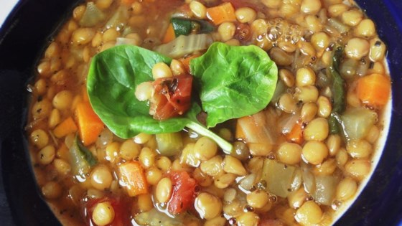

Lentil Soup

Ingredients
-15 onions chopped
-Carton of vegetable broth
-30 carrots peeled &
-30 stalks of celery chopped
-30 cloves of garlic minced
-1/3 cup dried Oregano
-1/3 cup dried basil
-15 bay leaves
-15 cans crushed tomatoes
-30 cups dry lentils rinsed
-120 cups water
-8 cups spinach, rinsed and thinly sliced (store for Thursday)
-1 ¾ cups vinegar
-Salt & pepper to taste

Directions
- Prepare all the ingredients as listed
- Divided between 2 large soup pots, heat vegetable broth (appox. 1 cm in bottom of pot). Add onions, carrots, and celery; cook and stir until onion is tender. Stir in garlic, bay leaf, oregano, and basil; cook for 2 minutes. Add more broth as needed to cook.
- Stir in lentils, and add water and tomatoes. Bring to a boil. Reduce heat, and simmer for at least 1 hour.
- When ready to serve stir in spinach, and cook until it wilts. Stir in vinegar, and season to taste with salt and pepper, and more vinegar if desired.

