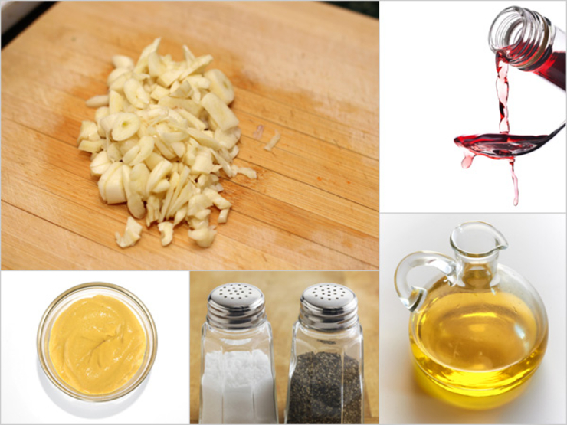

Little Bit of Vinaigrette
Drizzle this dressing over baby arugula or roasted asparagus. It also doubles as a dip for steamed artichoke leaves. For a very versatile vinaigrette, play with any Dijon flavor you want, like tarragon, course ground, or walnut. Mmm.
- 1 Tbsp extra virgin olive oil
- 1 tsp red wine vinegar (balsamic or champagne also work well)
- Salt and pepper, to taste
- 1 small clove garlic, chopped
- 1 tsp Dijon mustard
From the kitchen of Melissa Roberson
x15 for 40-60 people

