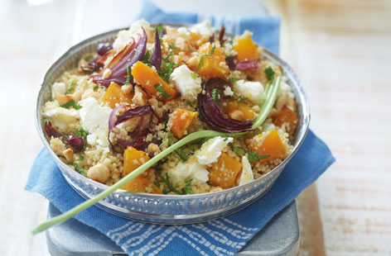
Moroccan butternut squash couscous salad

Ingredients
- 2 large butternut squash, peeled, deseeded, cut into small cubes
- 2-3 red onions, cut into fine wedges
- olive oil (enough to drizzle over squash and onions to roast
- 24 tsp Ras al hanout Moroccan Spice Mix (see separate recipe for 8tsp... x4)
- 6 cups of uncooked couscous
- 2, 900ml packs of broth, heated in pot on stove with 2 cups orange juice
- hazelnuts, roughly chopped (put on side)
- feta cheese, crumbled
- 2tbsp fresh mint leaves, chopped

Roast Squach & Onion with seasoning:
Preheat the oven to 200°C / 400 F. Scatter the butternut squash and onion wedges over two large metal trays found in bottom drawer of oven, drizzle with olive oil, scatter over the Ras al Hanout (separate recipe for spice mix on website), season well and roast for 30 minutes or until golden brown and tender one tray on each oven rack...trade places half way through. Turn occasionally to ensure it cooks evenly.

Put dry couscous in large bowl and add the HOT broth & orange juice, cover with cling film and leave for 4 minutes. Then fluff up with a fork and let cool. Add the roasted squash & onion, feta and mint (optional) before serving.

Serve the hazelnuts on the side.

