Nepal earthquake 2015: before and after in Kathmandu
Nepal's earthquake has damaged valuable cultural sites and forced 24,000 displaced people into camps that have sprung up across Kathmandu. Use the slider to see before and after aerial images.

Tundikhel

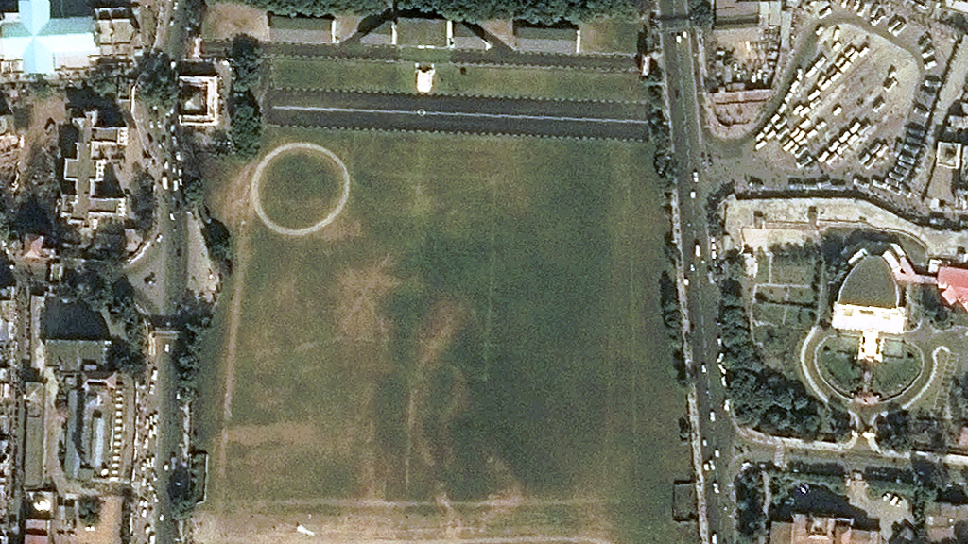
29 Nov 2014
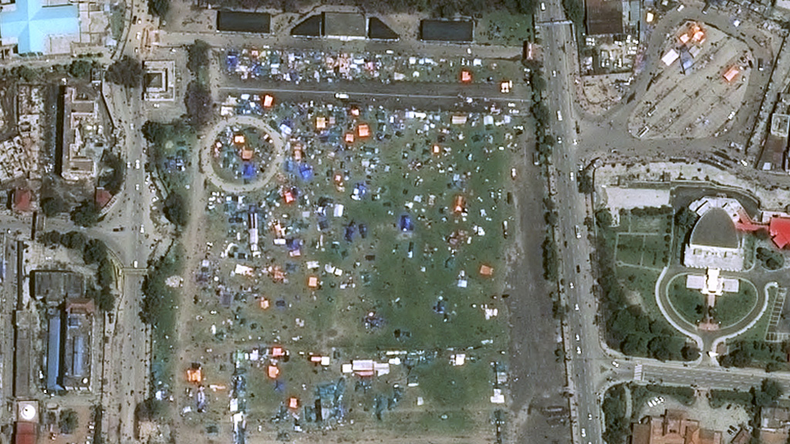
27 Apr 2015 Photo Credits: Before Airbus DS Geo After Airbus DS Geo
The large grassy area in the centre of Kathmandu, normally used for parades, has been transformed into a sea of tents for people displaced by the earthquake.
There are reports of as many as 15 people living in single tents and there are concerns about access to water. The UN says many people continue to sleep outdoors, in damp and cold conditions, for fear of falling debris from aftershocks.

Nepal's government has reported that 130 homes have been destroyed and 85,856 damaged.
The United Nations says 8 million people have been affected by the quake, with at least 2 million in need of tents, water, food and medicines over the next three months.
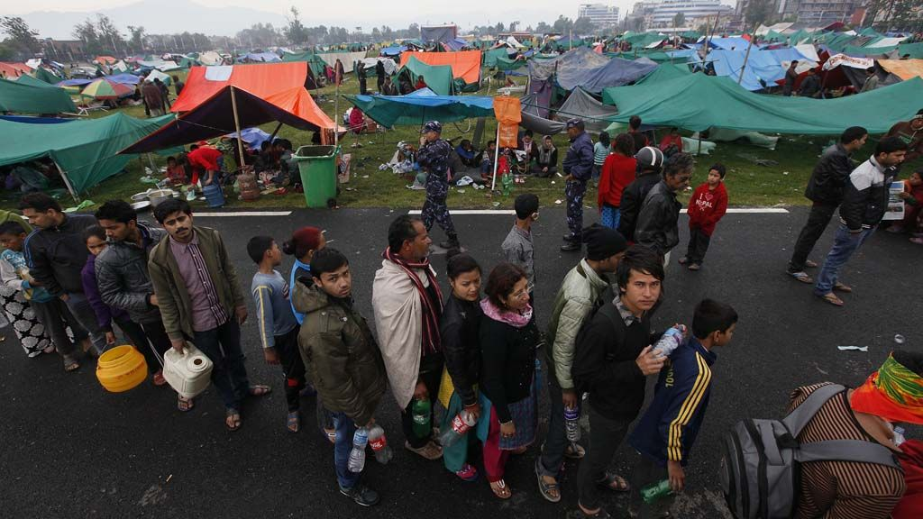

Kathmandu Durbar Square

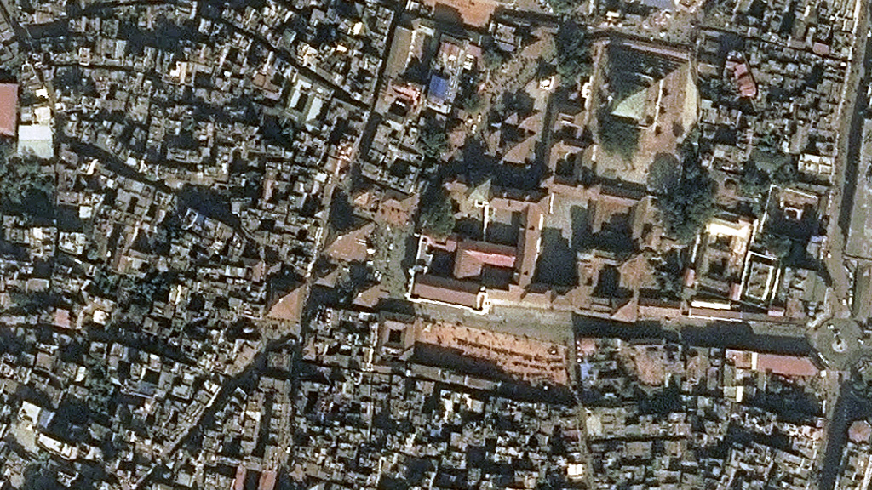
29 Nov 2014
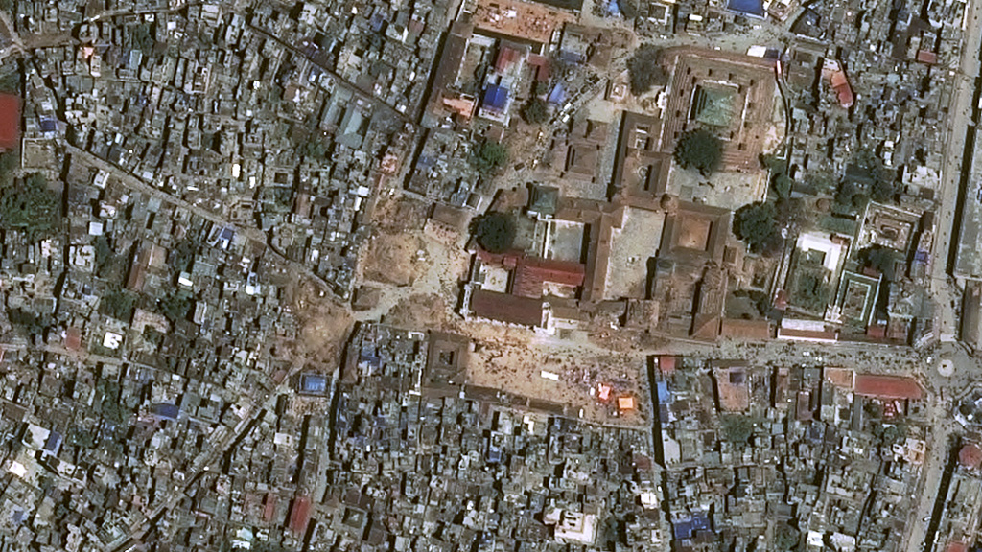
27 Apr 2015 Photo Credits: Before Airbus DS Geo After Airbus DS Geo
Several buildings have been destroyed or severely damaged in the Kathmandu Durbar Square, a Unesco World Heritage site, including the impressive 17th century Maju Dega temple.
It is one of three Durbar Squares (squares in front of Nepal's old royal palaces) to have been "almost fully destroyed" in the Nepal earthquake, Unesco said.
Irina Bokova, the director-general of Unesco, said she is "shocked by the devastating impact on the unique cultural heritage" of Nepal caused by the earthquake.
Parts of the square date back to the 16th century, and it is an important religious and cultural site for Kathmandu's residents.

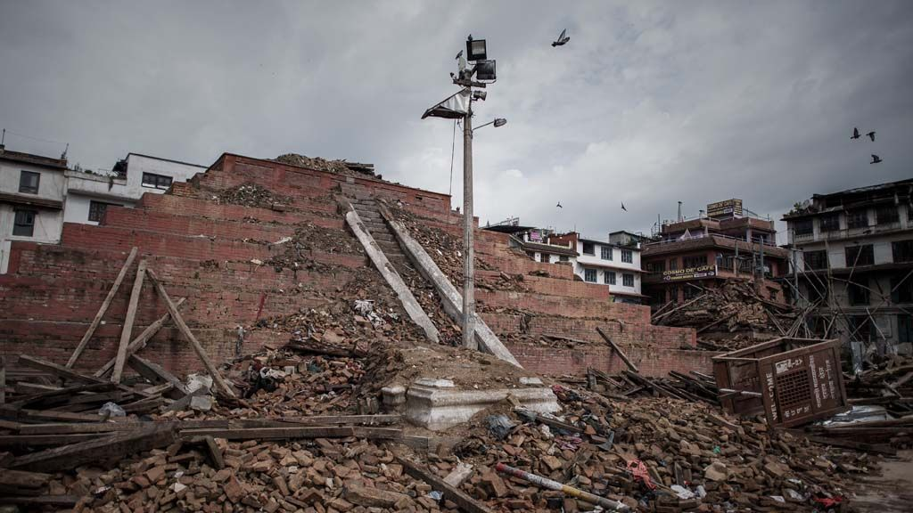

Dharahara Tower

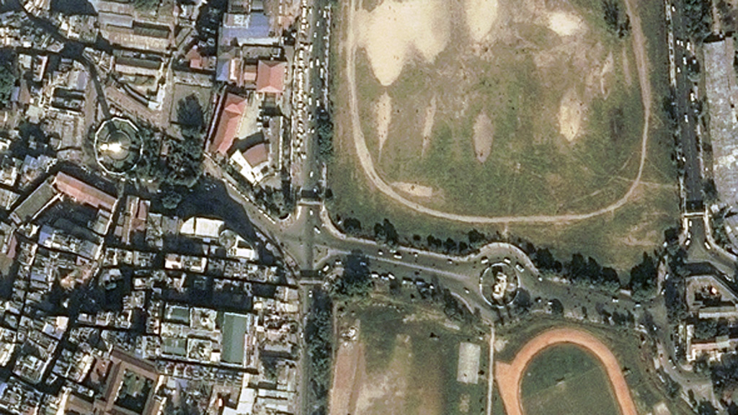
29 Nov 2014
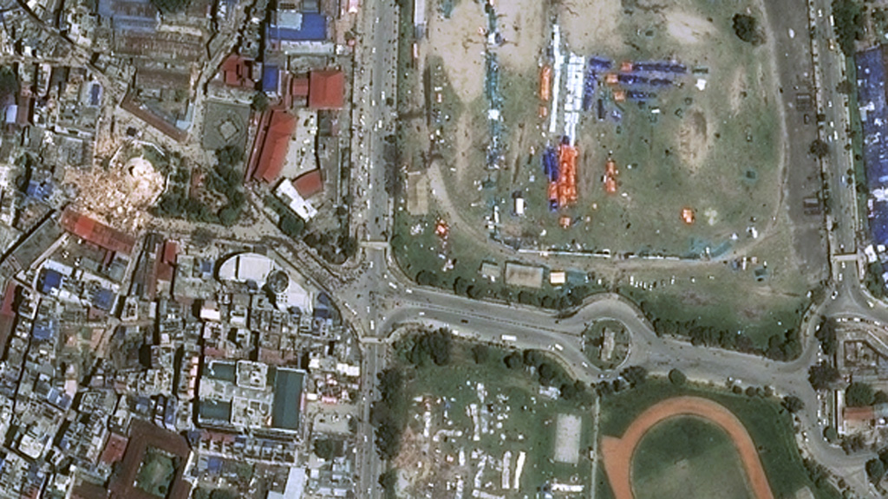
27 Apr 2015 Photo Credits: Before Airbus DS Geo After Airbus DS Geo
The nine-storey tower, which overlooks Tundikhel in the centre of the city, was built in 1832 by Nepal's ruthless former Prime Minister, Bhimsen Thapa. It survived an earthquake in 1834, but most of its storeys collapsed in Nepal's last major earthquake in 1934 and was subsequently rebuilt.
Many people were buried in the rubble after the tower, a popular landmark with panoramic views across the city, collapsed. The Daily Mail reported one man, Krishna Ramtar, miraculously survived despite being on the eighth floor when the earthquake hit. His mother-in-law and sister were not so lucky.
"Suddenly, everything started shaking, everything was spinning," Mr Krishna said. "We didn't know what to do, where to go… we were on such a height.”
"Then it was all darkness. All I remember after that was waking up in this hospital."

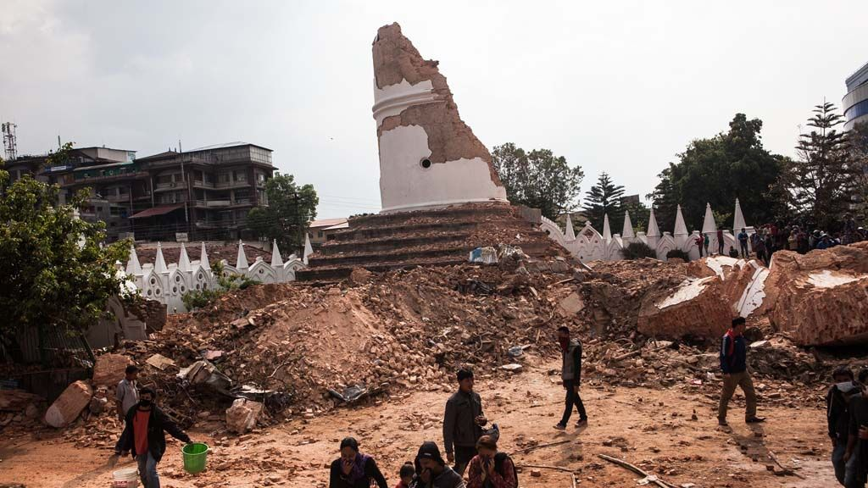

Narayanhiti Palace Museum

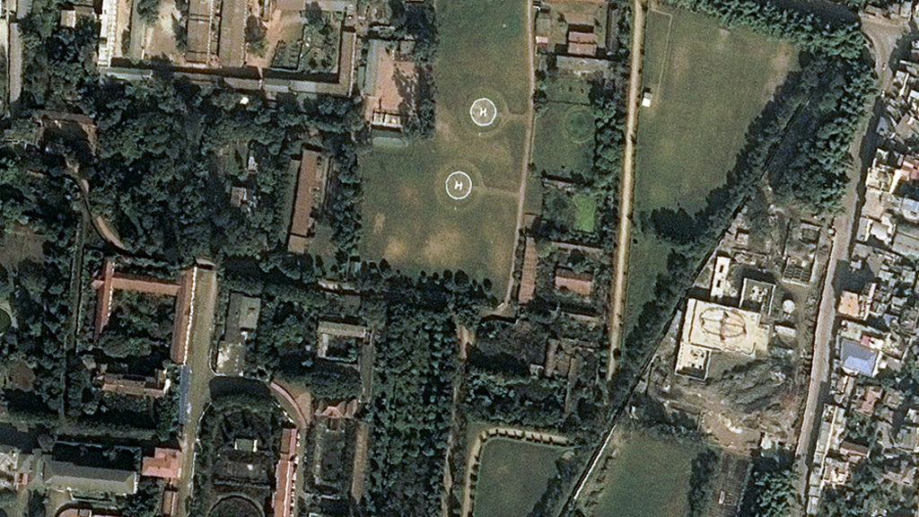
29 Nov 2014
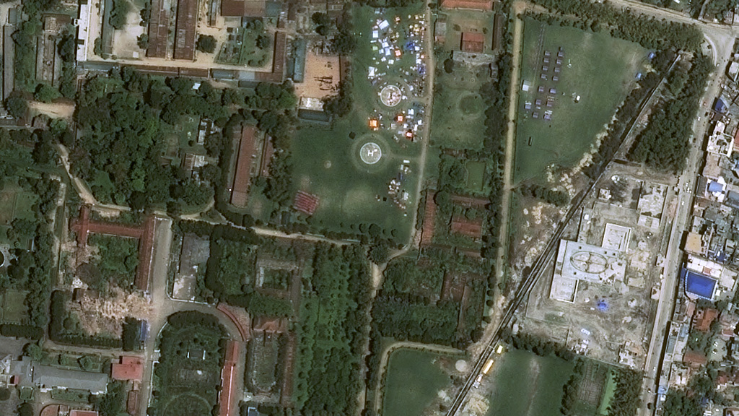
27 Apr 2015 Photo Credits: Before Airbus DS Geo After Airbus DS Geo
The Narayanhiti Palace, turned into a museum after Nepal became a republic, was the traditional residence of the king. The compound includes helipads that are now home to people displaced by the earthquake.
Buildings at the palace, one of the most visited sites in Nepal, have also been damaged.
- 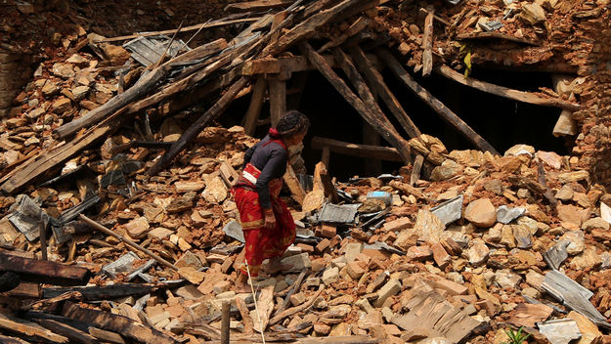

01 May 2015
- 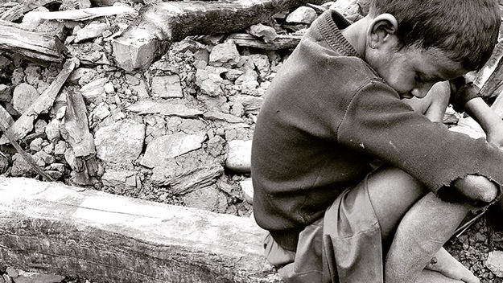

30 April 2015
- 