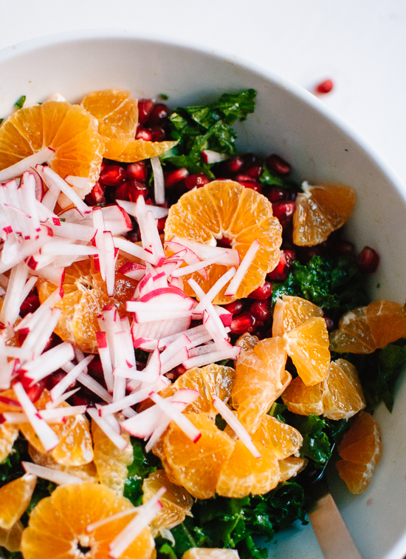
Orange Pomegranate Kale Salad
INGREDIENTS
Kale salad
- 8 bunches kale
- 8 avocados, diced
- 8 medium pomegranates—seeded
LOOK HERE:
https://www.youtube.com/watch?v=-qfQ3_N7S6Y
- 15 oranges, peeled and sliced into rounds
- 3 bunches radishes, sliced into thin rounds and then into skinny strips
- 2 bunches fresh cilantro, chopped
- crumbled feta
- pumpkin seeds

Honey-Lime Dressing
- 2 cups lime juice (about 2 small limes)
- 2 cups olive oil
- ½ cup honey
- ¼ cup Dijon mustard
- chili powder & salt to taste
INSTRUCTIONS
- First, make the dressing by whisking together all of the ingredients in a large glass measuring cup.
- Prepare the kale into ribbons removing large thick ribs. Transfer the kale to a big salad bowl. Sprinkle a small pinch of sea salt over the kale and massage the leaves with your hands by lightly scrunching big handfuls at a time, until the leaves are darker in color and fragrant.
- Drizzle salad dressing over the kale (you might not need all of the dressing) and toss well so the kale is lightly coated with dressing. Add the prepared avocado, pomegranate, orange, radishes, cilantro. Mix these together on Wednesday and store in fridge.
- Add avocado, feta & pumpkin seeds on Thursday

