FREEZE HOT PEPPERS
- wash, cut off stems, cut in half and remove seeds. Let dry
- put them in thick ziploc bags designed for the freezer. Label and date and throw ’em in the freezer.
- All hot pepper varieties freeze well, whether they’re thick or thin-skinned.

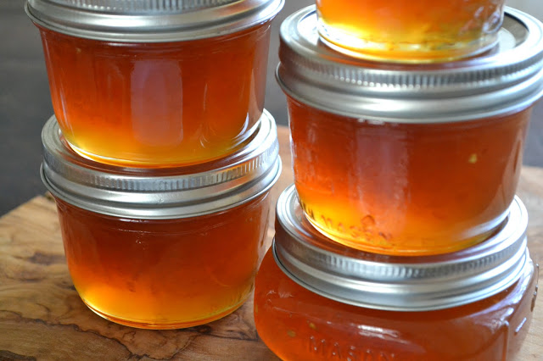
LATER… HOT PEPPER JELLY

Ingredients
- 2 cups coarsely chopped peppers
- 2 cups cider vinegar
- 6 cups granulated sugar
- ¼-1/2 tsp crushed chile flakes
- 2 pouches (each 3oz/85 mL) liquid pectin
Instructions
- Prepare canner, jars, and lids:
- Place 12 4-oz jars in large canning pot. Add enough water to fill jars to the top and just cover them with water. Bring water to a low simmer (do not boil).
- In separate sauce pan, cover lids with water and bring to a gentle simmer. Keep lids hot until you need them, then remove with tongs. Wash screw bands with soap and water and rinse thoroughly - do not heat them, you want to be able to handle them.
- In blender purée peppers and 1 cup vinegar until smooth.
- In large, deep stainless steel pot, combine pepper puree, remaining 1 cup vinegar, sugar, and crushed chiles. Bring to a boil over high heat (it will bubble up significantly - use a large pot!) Boil, stirring constantly, for 10 minutes. Stir in pectin and boil hard, stirring constantly, for 1 more minute. Remove from heat and quickly skim off any thick foam.
- Quick pour hot jelly into hot jars, leaving ¼" headspace. Wipe rims of jars to ensure they are clean. Center lid on jar and screw band on until fingertip tight (don't over-tighten).
- Place jars in canner, ensuring they are completely covered with water. Bring to a boil, put lid on canner, and process for 10 minutes. Remove canner lid and turn off heat. Wait 5 minutes, then remove jars, keeping them as straight as possible, to a flat surface where they can sit for 24 hours. Don't dry them at this point, any water on the tops will evaporate on its own.
- After 24 hours, check all lids for seal - you should hear them popping quite quickly as they seal, and the lids should not flex when pushed after 24 hours. If any have not sealed, store in the fridge and use within a month. Canned jars are best used within a year.

