Potato Wedges Prep
You will need approximately 80 potatoes… when you are done they should fill 2-3 of the flatter plastic containers… potatoes are in boxes in foyer to courtyard…
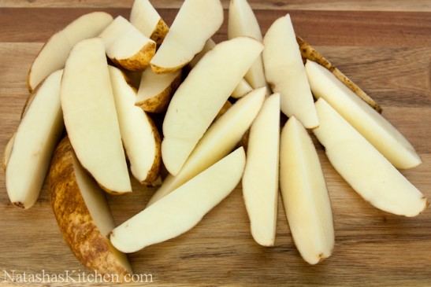
1. Wash and scrub potatoes clean
2. Use potato wedger to cut into 4, then cut lengthwise again for 8 wedges each OR if small potatoes cut by hand into quarters
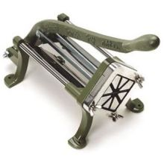
2. Place potatoes in plastic containers completely covered IN WATER!!! Or they will go black… YUCK!
3. Store in fridge
4. on Thursday Salad Bar day…. at 9 am preheat 6 ovens in Mrs. Campbell's room to 450 degrees
5. put warming tray on with water in it to heat up in canteen
6. at 9:30 am bring down potatoes… drained of water and mixed with olive oil and sea salt, along with 6 baking trays, large spoon for scooping, and spatula
7. distribute potatoes onto 6 trays and put in ovens baking at 450 degrees F for 45 minutes… can put on broil for last 10-15 if needed.
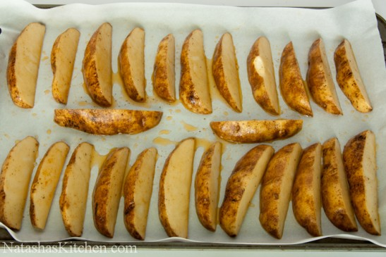
8. Take out of ovens when ready and put into two large flat warming trays with lid… put one in canteen oven to stay warm at 200 degrees and the other into the warming tray ready to serve

