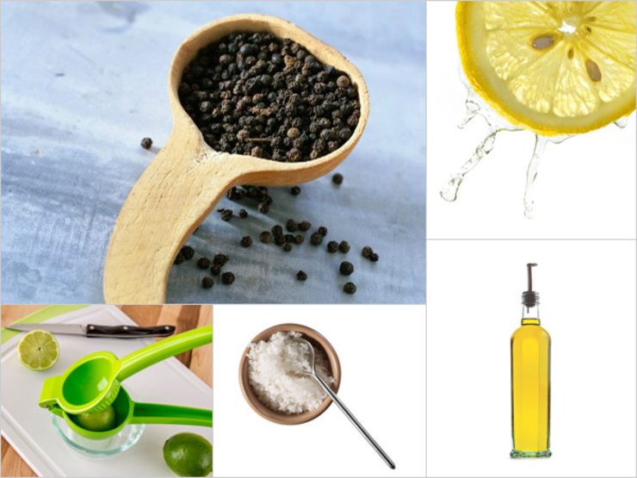

The Quick and Clean
Even with a barebones pantry, you can still make the perfect salad dressing. This one is so foolproof you don’t even need measurements—and yet, peoplestill ask us for the recipe.
- Fresh lemon juice
- Fresh lime juice
- A little bit of extra virgin olive oil
- Salt, to taste
- Coarse ground pepper
From the kitchen of Jenna Bergen

use 8 lemons and 8 limes for 40-60 people + equal volume olive oil

