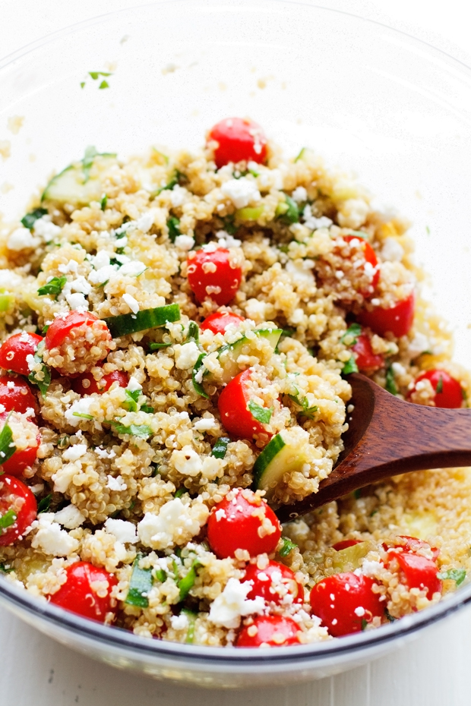

Quinoa, Cucumber, Tomato Salad
-15 cups raw quinoa prepared according to directions on package and stored in fridge
-8 cucumbers washed, sliced and quartered and stored separately until Thursday
-15 tomatoes washed and diced and stored separately until Thursday
-2 bunches green onions washed, dried, chopped and stored separately until Thursday

Balsamic Dressing
-mix balsamic vinegar & olive oil + Italian seasoning until it tastes good :-)

