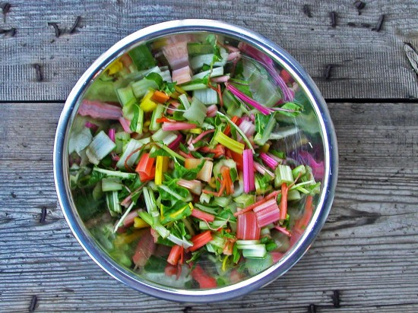
Rainbow Chard Salad with Cranberries, Almonds & Feta

Ingredients
4 lbs rainbow chard, washed, spun dry and chopped (can include stems without any rough ends)

10 Tbsp. olive oil
10 Tbsp. balsamic vinegar
10 tsp. salt
freshly ground black pepper
4 bunches radishes, thinly sliced
6 shallots, minced
3 cups dried sweetened cranberries
3 cups almonds, toasted
3 cups crumbled feta cheese
4 bunches parsley
6 avocados
Directions
Wash the chard very well and spin dry. Thinly slice, taking special care to slice the ribs particularly thinly. Prepare other ingredients.
On Thursday Morning--Add the olive oil, vinegar, salt and pepper to the chard. Massage it well for about 15 seconds or so.
Add the radishes, shallot, cranberries, almonds, feta, parsley and avocado. Toss lightly to combine.

