Raspberry, Rosemary Vinaigrette Dressing:
Mix in Blender:
- 3/4 cup vinegar
- 3/4 cup olive oil
- 1 cup frozen raspberries (add more if needed)
- 3 TBSP honey
- 6 tsp minced onion
- 6 tsp chopped chives
- 6 tsp chopped fresh rosemary --from the courtyard --huge bush by apple tree to right of wooden arbor)
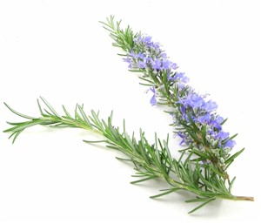
- salt & pepper to taste

