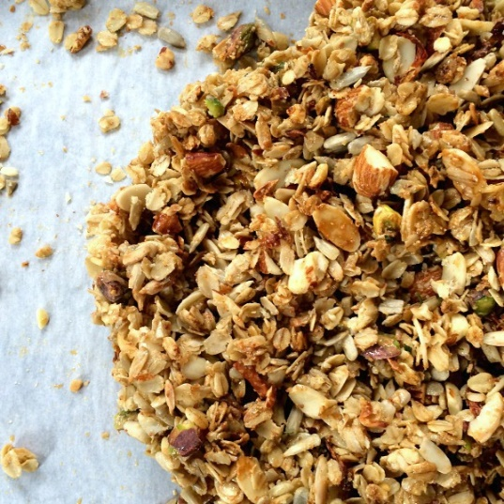
Parmesan Rosemary Savory Granola
This has the demeanor of your favorite crackers with better flavor. It's great added to creamy soups, crisp salads, snack platters or eaten by the fistful.
Prep Time 15 min Cook Time 25 min
Ingredients
- 6 cups Rolled Oats
- 2 cups Sunflower Seeds, unsalted
- 1.5 cup Unsalted Almonds, chopped
- 1.5 cup Unsalted Almonds, sliced
- 1 cup Unsalted Pistachios, shelled and chopped
- 6 Tbsps. Flax Powder
- 1 tsp. Salt
- 2 tsp. Garlic Powder
- 1.5 tsp. Onion Powder
- 4 tsp. Fresh Rosemary, diced from garden
- 2/3 cup Parmesan Cheese, packed
- 2/3 cup Canola Oil
- 1 cup Brown Rice Syrup
Instructions
- Preheat oven to 325 degrees and line a cookie sheet with parchment paper.
- Combine the dry ingredients in a bowl, from the rolled oats to the parmesan cheese.
- Add oil of choice, stirring to coat everything. Add brown rice syrup, stirring again to coat everything. Once combined, spoon mixture onto a baking sheet. Leave clumped together. Do not spread out on the baking sheet.
- Bake at 325 for 25 total minutes, stirring at the 10 minute and the 20 minute mark. Remove from oven and let cool for at least 30 minutes and up to overnight. It will keep in an airtight container for several weeks.
By Meghan McCarthy

