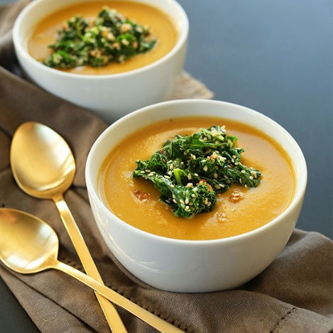
SIMPLE PUMPKIN SOUP

A simple, 7 ingredient pumpkin soup that's savory and made completely from scratch! Healthy, satisfying, and perfect for chillier weather.
Author: Minimalist Baker
Ingredients
SOUP
- 3 frozen Ziploc bags of pumpkin puree thawed in previous week in
- 16 onions diced
- 30 cloves garlic, minced
- 30 cups vegetable broth—make from jar concentrate according to directions
- 16 cups light coconut milk
- 2 cups maple syrup to taste
- sea salt, black pepper, cinnamon, nutmeg to taste

Instructions
- Take out already prepared frozen pumpkin puree to thaw on Friday before Salad bar with soup
- Make Soup COLD before salad bar (will need to split into 2 large pots dividing all ingredients)
- Make up Vegetable Broth and put in pots and add pumpkin puree plus coconut milk & Maple syrup
- Chop onion and garlic and Sautee in olive oil and divide into both pots
- Add remaining ingredients
- Transfer soup mixture in batches to blender to puree the soup. Pour mixture back into pots.
- Store in fridge until Thursday morning then heat slowly starting first thing for salad bar

