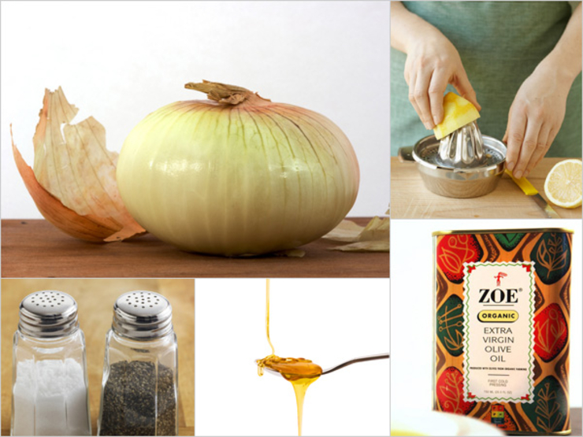

Siobhan's Special
Bust out this secret weapon at your next dinner party. Guests go crazy for this classy and crazy-easy dressing.
- 2 small cipollini onions pulverized in a food processor
- 1/3 c extra virgin olive oil
- 1 tsp honey
- 3-4 Tbsp lemon (or more if needed)
- Salt and pepper to taste
From the kitchen of Siobhan O’Connor
x4 for 40-60 people

