Spinach, Pasta, tomato and mozza salad with courtyard garden herbs

Ingredients
Serves: Makes 8 servings.
- 3 pkg pasta
- 1 1/4 cups olive oil
- 1 1/4 cups white wine vinegar
- 2 1/3 tablespoons finely crushed rosemary from courtyard garden
- 2 1/3 tablespoons thyme leaves from courtyard garden
- 3 1/2 teaspoons garlic powder
- 3 1/2 teaspoons oregano leaves from courtyard garden
- 3 1/2 teaspoon Sea Salt
- 2 lbs spinach leaves (or other greens) washed and spun dry
- 5 containers grape tomatoes, halved
- Shredded mozzarella cheese
- 1 cup grated Parmesan cheese
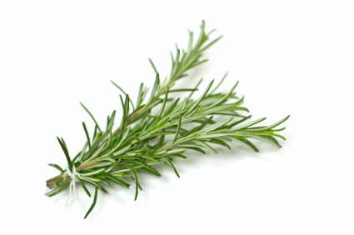

Rosemary-- in courtyard by apple tree... to right of wooden arbor

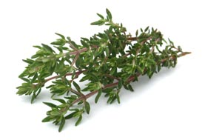

Thyme-- along vegetable garden border...just beside fountain
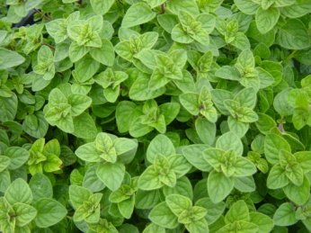

Oregano-- in pot just outside courtyard garden door where ping pong table gets set up

Directions
- Dry rosemary, thyme and oregano leaves between two sheets of paper towel in microwave at 1 minute intervals and then crush-- see Heather about this.
- Cook pasta as directed on package. Drain well and rinse... add some olive oil so it won't all stick together
- mix oil, vinegar, rosemary, thyme, garlic powder, oregano and sea salt in large bowl with wire whisk until well blended. Add pasta and spinach; toss to coat well. Add tomatoes and cheeses; toss to mix well.

