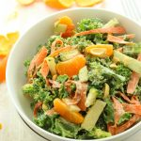
Chopped Tahini Kale Salad

Tahini Dressing
- 2 cups tahini
- 3 cups white wine vinegar
- 1 cup maple syrup or honey
- 1 ½ cups Tablespoons orange juice
- 8 cloves garlic, minced
- 8 teaspoons sea salt
- 8 teaspoon pepper
- 8 teaspoon ginger
*make in blender and store in covered measuring cup in fridge

Salad
- 8 bunches kale, de-stemmed
- 20 mandarin oranges
- 12 carrots ribboned
- 8 green apples, chopped
- 6-8 crowns broccoli, chopped
Peanuts on the side
*prep all ingredients in labelled containers in fridge

