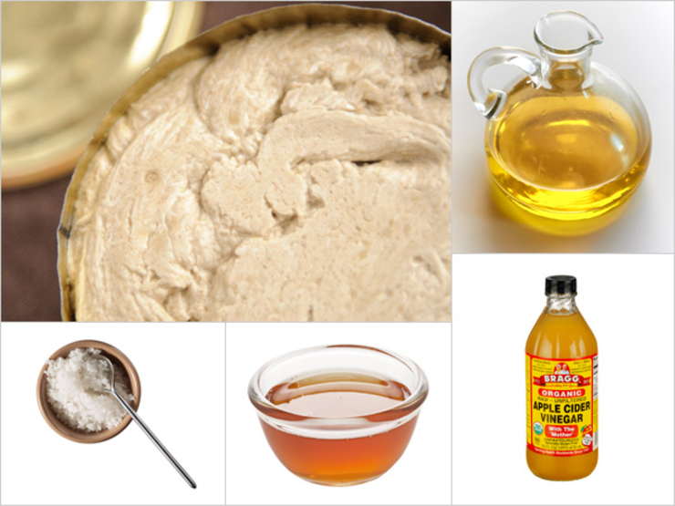

The Creamy Tahini
This silky, spicy dressing makes bitter greens a joy to eat. Try to eat just one bowl of salad—we dare you.
- 1 part apple cider vinegar
- ½ part sesame oil
- ½ part extra virgin olive oil
- About 1 part tahini (more or less to your preferred consistency)
- Pinch of salt
From the kitchen of Mandy Oaklander

For 40-60 people
1 cup apple cider
1/2 cup sesame oil
1/2 cup olive oil
1 cup tahini
Salt to taste

