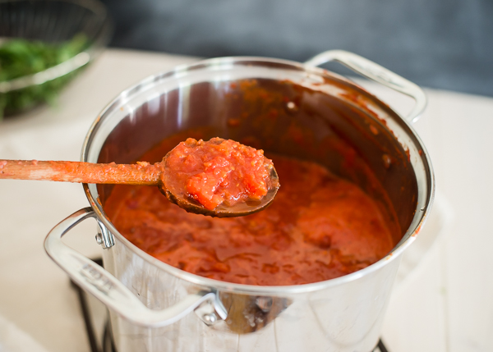
How to Make & Freeze Homemade Tomato Sauce
Prep Time: 30 minutes
Cook Time: 3 hours
Total Time: 3 hours, 30 minutes
Yield: About 12 cups X5 for one salad bar batch x10 for 2 salad bar batches
Ingredients
- 10-11 pounds fresh tomatoes
- 6 tablespoons olive oil
- 3 medium onions, diced
- 6 garlic cloves, minced
- 2 (4-ounce) cans tomato paste
- 1-3 teaspoons sugar or honey, to taste (optional)
- 1/2 cup chopped fresh herbs or 2 tablespoons dried Italian herbs--- Use from courtyard garden if able
- 1 tablespoon salt, plus more to taste
- 1/2 teaspoon freshly ground black pepper, plus more to taste
Instructions
Prepare the tomatoes:
- Have a large bowl filled with cold water ready and waiting. Set a large pot of water over high heat and bring to a rolling boil. Working in batches, drop the tomatoes in one at a time, then let sit in the boiling water until the skins split open, 30-60 seconds. One at a time, remove tomatoes from hot water with a slotted spoon and transfer to the bowl of cold water. When cool enough to touch, slip off and discard the tomato skins and remove the hard stem end and core. Trim away any bad spots. Roughly chop the tomato using a food processor or blender, a knife, or by squishing with clean hands. Set aside.
Make the sauce:
- Add the olive oil to an extra-large 8-10 quart stock pot over medium-high heat. When the oil is shimmering, add the diced onions. Cook, stirring frequently with a large wooden spoon, until onions start to soften and turn golden, about 8 minutes. Add the garlic and cook for another 30-60 seconds, stirring constantly so it doesn't burn. Add the tomato paste and cook for 1-2 minutes, stirring and scraping the bottom of the pan so it doesn't burn. Add the fresh tomatoes.
- Bring just to a boil, then lower heat to medium-low and let simmer, uncovered, for 2-3 hours, until thickened. Stir occasionally to make sure the sauce at the bottom of the pan isn't burning.
- Add sugar or honey, if desired, along with the herbs, salt, and pepper. Taste and add additional salt and pepper if needed.
Freeze the sauce:
- Let the sauce cool completely. Pour into to freezer-safe containers or heavy-duty freezer bags. Label well with date and contents, then transfer to the freezer. The sauce will last 3-4 months, or longer if you use a deep freeze.
Notes
The yield is approximate, depending on how much the sauce cooks down.

