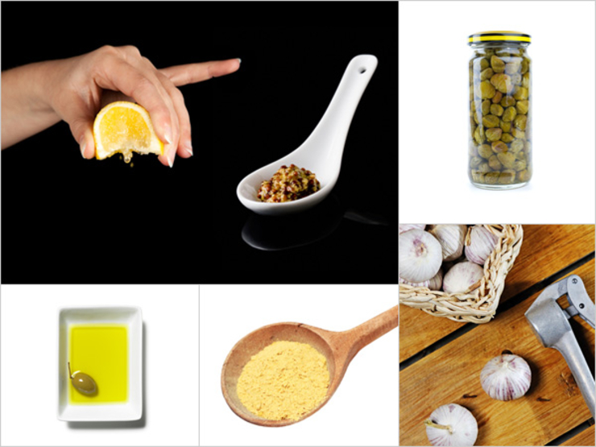

Vegan Caesar
This vegan version eliminates so many classic Caesar ingredients—mayo, anchovies, and cheese—that we felt justified at 6 ingredients. And you won’t believe how good it tastes! It’s too good to limit to greens: We love it on roasted veggies, drizzled on buttery toast, melted over popcorn, or sprinkled on homemade tacos. Season with salt and pepper to taste.
  - 1/3 c extra virgin olive oil
  - 3 heaping Tbsp nutritional yeast
  - 2 tsp Dijon mustard
  - 1 tsp caper juice
  - 2 cloves garlic, pressed
  - 2 tbsp lemon juice
From the kitchen of Siobhan O’Connor
x 6 for 40-60 people

