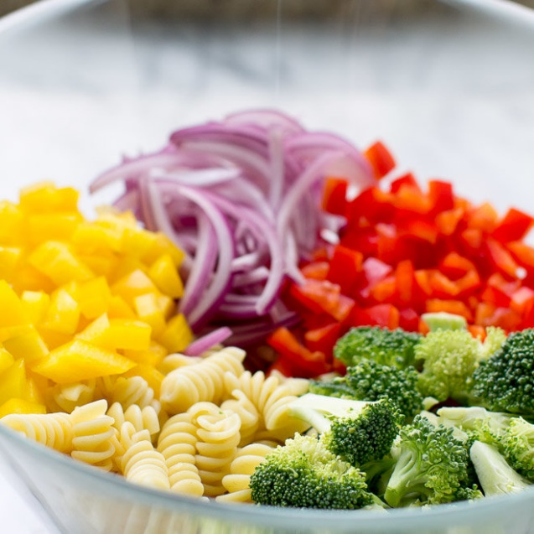
Zesty Rotini Salad

*Combine EVERYTHING ahead of time in the two stainless steel trays with lids

INGREDIENTS:
- 2, 900 g packages of rotini or other pasta
- 12 cups bite-sized broccoli florets (from 1 head broccoli)
- 6 red bell pepper, chopped
- 6 yellow bell pepper, chopped
- 3 red onion, peeled and cut into strips
- 4 cups feta cheese
- 1.5 cups canola or other veg. oil + 1.5 cups balsamic vinegar + Italian seasoning to taste

DIRECTIONS:
- Cook pasta as per package instructions. Drain well, rinse with cold water, and drain again.
- Meanwhile, combine broccoli florets, bell peppers, and onion in a large bowl. Stir in cold pasta. Add feta cheese and salad dressing and toss until uniformly combined.
- Put in two stainless steel serving trays with lids. Chill at least 2 hours before serving.
- Stir carefully before serving. Add more salad dressing as needed to keep the pasta from drying out.

